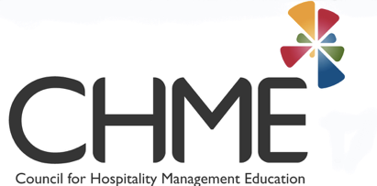
CALL FOR PAPERS AND POSTERS
27th Council for Hospitality Management Education (CHME) Annual Research Conference
Innovation in Hospitality: Connecting stakeholders to deliver memorable experiences
22th-25th May 2018 Bournemouth University, UK
Bournemouth University is proud to host the 27th Council for Hospitality Management Education’s Annual Research Conference in May 2018.

The hospitality industry strives to cope with the changing forces in the environments in which it operates. Such changes are multifaceted and driven by dynamic economic, political, social and technological forces. Innovation in hospitality is crucial so that all stakeholders can offer improved and memorable customer experiences in a situation of flux. The Council for Hospitality Management Education conference is the best avenue to drive our agenda for research and learning in hospitality with regards to products and services, process, marketing, people and institutional innovation. The conference theme relates to innovative practices in all aspects of the hospitality experience including in hospitality education.
There is also growing academic interest in issues related to the hospitality experience such as the sharing economy, talent management, technology and distribution, food innovation and design, crisis and risk management and gender and religion. The CHME18 conference invites contributions within the following main themes:
- Hospitality Management
- Learning, Teaching, and Assessment in Hospitality
- Critical and Cultural Studies in Hospitality
- Today’s and Tomorrow’s Consumer
- Technology and Innovation in Hospitality.
Other relevant thematic areas include:
- Experiences and consumers of the future
- The sharing economy and challenges to commercial hospitality
- Collaborative consumption and co creation
- Management of talent in the hospitality industry
- Human Resource Management and Leadership in hospitality
- Technology and distribution
- Food innovation and design
- Luxury vs functionality
- Gender and religion
- Female leadership in hospitality
- Crisis management, risk management, safety and security
- The future of hospitality.

We also invite workshop contributions from industry stakeholders and practitioners under the theme: ‘Innovation in hospitality and tomorrow’s consumers’. We would like to engage industry professionals and government officials in a dialogue on how to best utilise our education and research outputs for the benefits of the industry and to share best practice.
The deadline for submissions is Friday 26th January 2018. Papers and posters should be submitted to:
papers@chme18.org
posters@chme18.org

Industry workshop proposals should be submitted to:
hosman@bournemouth.ac.uk

For more information please contact CHME2018 Chair, Dr Hanaa Osman

hosman@bournemouth.ac.uk

For full details of the conference and paper, poster and workshop guidelines, please visit the conference web site:
http://www.chme.org.uk/news/2017/06/01/2018_CHME_Annual_Research_Conference/

