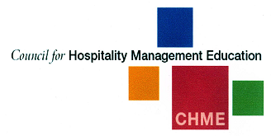 |  | CHME  - Newsletter  - 2014 No.1
2014 |  | In This Issue

During the year, we welcomed Tony Loynes, University of Derby, to the Executive. We would like to extend our warmest thanks to David Jenkins, University College Birmingham, and the CHME-Path committee who are leaving office for all their excellent work. We are looking forward to a representative on the Executive from Manchester Metropolitan University which will be host institution for the 2015 CHME Research Conference.
We had a fantastic conference in May 2013 in Edinburgh. There were some excellent keynote speakers such as Professor Alison Phipps OBE, University of Glasgow; Professor Angela Roper, University of West London; Albert Roux OBE and Legion D’Honneur; Peter Ducker, Chief Executive, Institute of Hospitality. We had a wide range of participants from some 17 different countries presenting across a range of themes relating to hospitality management, hospitality education, critical and cultural hospitality studies, food and drink and sustainable hospitality.
CHME’s student conference has now been replaced with the Institute of Hospitality’s student conference and Passion for Hospitality (P4H) debate. This year the conference and debate ran alongside the HOTS competition ran by Arena 4 Finance. University College Birmingham hosted the whole event and the 3 events in 1 appeared to work well over the day. It was good to see students from a number of CHME institutions from across the UK in attendance at all 3 events.

Co- Chairs report 2013/14
by Paul Lynch and Crispin Farbrother
Taking the Young Guns competition on in 2013 was of some success with significant sponsorship and support from Tim West at Lexington. His commitment to CHME, particularly through Young Guns is excellent. Its continued success is only guaranteed if member institutions put students forward for the award of best student and, with the 10 top places awarded, we believe that all member institutions across the UK should enter their students into this fantastic competition. We are open to other suggestions regarding future events involving students.
We are delighted to have David Litteljohn and Stephen Ball as CHME Executive Ambassadors whose voluntary role is concerned primarily with increasing institutional membership as part of a

Co- Chairs report
A column break is inserted before and after each column that acts as a sidebar. To insert a column break, press Ctrl+Shift+Enter. Or, on the Page Layout tab, in the Page Setup group, click Breaks, and then click Column.
Page 1/2

CHME 2014 University of Derby Buxton
To view column breaks, section breaks, and other formatting marks, on the Home tab, in the Paragraph group, click the pargraph mark icon.
Page 3/4
major drive as well as raising CHME’s profile.
We are conscious of needing to promote CHME internationally and for this reason are further strengthening our international links. It is good to see a growing number of international member institutions. During the year we have introduced international representation on to the Executive to ensure the voice of overseas institutional members is heard. So, we now have representation from the University of Auckland and are looking to expand representation from other global regions. We continue to look for ways of increasing membership benefits for international member institutions.
During the year, after several years of keeping fees frozen, we have made a small increase to membership fees in recognition of the increased membership benefits now experienced. We also have encouraged membership through occasional special deals for institutions which have not previously been members. CHME continues to be the official sponsor of the journal Hospitality & Society which seeks to advance theoretical developments in hospitality and thereby raise the academic profile of the subject. During the year, we agreed in principle with the publishers Intellect that CHME representatives would receive electronic access for personal use.
We remain very cost conscious and have introduced virtual executive meetings during the year with a more limited number of face-to-face meetings. We will also continue to work to a tight budget in order to maximise member value and benefits.
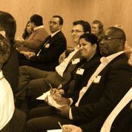
During the year, we accepted the resignation of the CHME-PATH committee. We would like to record our thanks to the sub-committee members for their work over the years. However, we feel it is timely to update the role of the sub-committee in order to ensure greater relevance to the demands of contemporary hospitality management education and to ensure working more closely with the executive committee in pursuit of CHME’s aims with regard to industry engagement. Accordingly, a new revised CHME-PATH was launched at the 2014 CHME Research Conference.
We have regular liaison / lobbying with relevant organisations including the Academy for Social Sciences; Higher Education Academy; People First; Springboard and of course the Institute of Hospitality.
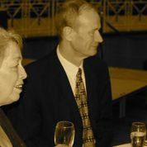
We are raising CHME’s profile and have developed a strong marketing strategy to further raise the profile and work of CHME including through significant improvements to the CHME website. One such improvement is the external examiner database on website which is now operational. We would encourage all institutions to promote the database to their staff and encourage further registrations in order to further develop this important service. Our profile continues to be enhanced through the growth of our LinkedIn sites and the launch of our Twitter account @CHME2013. Please do get involved, join the two CHME LinkedIn groups; Council for Hospitality Management Education and CHME-PATH and follow us on twitter. Please feel free to use them to promote your own organisation’s activities and events. Let us use them as a celebration of what we do best as institutions. We have also continued with the practice of sending CHME membership certificates to all members and would encourage you to display them somewhere conspicuous.

Crispin Farbrother
Paul Lynch
Co-Chairs
Council for Hospitality Management Education (CHME)

2014 CHME Conference reports Buxton
We both attended the 2014 CHME Research Conference in at the University of Derby, Buxton campus last month. As (first-time) delegates from the continent, we were asked to share our feelings about the conference in this newsletter. Of course we are more than willing to oblige!
First of all, we’d like to congratulate the University of Derby for the outstanding organization and flawless logistics of the conference. What stood out for us most, was the generally very positive 'atmospherics' – as it was called in one of the break-out sessions: very amiable and informal. With some exaggeration, you could say we felt as if we’d been attending the conference for years. Another definite plus was the broad range of topics, which enabled us to attend sessions in our respective areas of interest. In those, once again the informal and open approach of most speakers invited lots of questions, constructive feedback and other comments. In most cases, probably, both speakers and audience benefited from this. The latter was definitely the case for our own presentations, in the areas of Revenue Management and F&B respectively, helping us to develop our research. Discussion ensued during, not just after the presentation, and brought us new ideas and suggestions to use in follow-up studies and other future research projects.
On a critical note, we believe that perhaps some sessions, including one or two keynote addresses, did focus a bit on an exclusively U.K. context and were therefore not necessarily relevant to us and other
delegates. Still, this will not stop us from returning to CHME 2015 in Manchester.
Stan Josephi, Rob van Ginneken
NHTV University of Applied Sciences
Academy of Hotel Management
Breda, the Netherlands

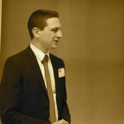

LUke SLater MSc student University of Plymouth

It was a real privilege to attend the recent CHME conference hosted at the Dome in Buxton. Being new to the academic conference scene, I was impressed at how easy it was to talk to the other delegates and how willing people were to share new ideas and concepts of their current research. As a current MSc International Hospitality Management student at Plymouth University, it was great to hear our voices being heard and represented at the conference; a recurring theme of what students want, what institutions can provide and what the industry needs was exciting to listen to, although I couldn't help but feel a little sad that my days of studying are somewhat numbered!
The opportunity to present a research paper was one that I simply couldn't miss and the positive feedback instilled new confidence in my own research methods. I hope that some of the new contacts I made will be able to assist me with my research in the future and if nothing else, act as a sounding board for new research ideas. With this in mind, I feel passionate about getting more students to attend academic and industry conferences as education moves forwards. With an increase of tuition fees and the ever increasing demand of value for money, I believe this could be a critical component of achieving high levels of student (customers!) satisfaction. This was my second academic conference, my first was in January 2014, the ICC5 Cruise Conference where I was fortunate enough to present a different paper. On both occasions, I have walked away with a feel-good factor, increased confidence and of course, new knowledge. I see the future challenge as the convincing of students to attend such events, particularly when they would likely be non-compulsory events. However speaking as a current student, if industry professionals can be encouraged to attend too, this will no doubt act as the final motivator for students attending. Regardless of whether this can be achieved, I believe that networking, knowledge and exposure to a professional event are three elements which can be used towards increasing the value of higher education.
It is my sincere hope that in the future, we can encourage more student-business and student-academic institution interaction. Students honestly do gain a lot from doing so. In line with the recurrent theme previously mentioned, the future of hospitality education lies within striking a balance between business and student demands. On a personal note, I believe that attending conferences such as CHME not only add value to higher education, but provide students with new opportunities to learn and develop skills which will no doubt benefit them as they move forwards into their chosen profession.
New CHME Fellows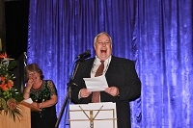
Two new Fellows were Honored at the recent CHME Research Conference- Philippe Rossiter and Professor Roy Wood.
Both Philippe and Roy have joined the prestigious list of CHME Fellows who have all dedicated their working lives to the hospitality industry and academia.
Photographs show Philippe proudly displaying his certificate and Roy entertaining guests during his acceptance speech.

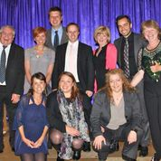
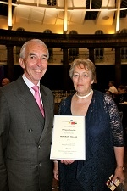

Best Paper Awards CHME 2014
Erwin Losekoot a lecturer and PhD student from Auckland University of Technology recently won the Best Paper in the Critical Studies Stream at the CHME Research Conference in Buxton- the video link provides a review of Erwin's research and his reaction to winning this award. Enjoy!
http://www.youtube.com/watch?v=ikUvj5txuHI
Other Best Paper stream winners were:

Hospitality Management - Rob van Ginneken and Alinda Kokkinou - The Role of Tasting Note Descriptors on Customers' Pre-Purchase Evaluations of Wine in a Restaurant Setting
Teaching, Learning and Assessment - Violet V Cuffy - Collaborative Planning for Lifelong Tourism Education and Training
The Role of the Employer - Dougie Yourston - University of Gloucestershire's experiences of curriculum development: the dilemma of meeting industry as well as academic needs.
Technology and Innovation - Francisco Tigre Moura and Vanessa Menezes - The Perception towards Mobile Application Features of the Hotel Industry: A Comparison between Hospitality Professionals and Guests.

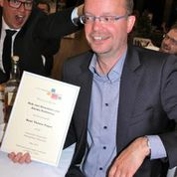
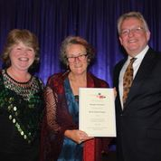
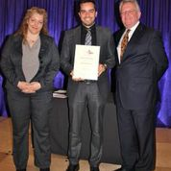
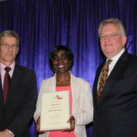

CHME and IOH special offer to students of CHME Universities and Colleges
The Institute of Hospitality worked together with the CHME executive to develop a unique promotional offer open to the students of all member institutions of CHME
All graduates are offered a membership from now through to December 2015 at the very special introductory rate of £50 - saving students £150. Students will become an associate member, entitling them to use the post nominals AIH after their name, and have full access to all of the IOH resources.
To find out more visit: https://www.instituteofhospitality.org/docs/chme_promotion_2014
Hospitality Management students’ perceptions of a career in the industry: time for a new research agenda?

One of the major challenges for the hospitality industry is to attract and retain highly-educated and highly-skilled employees. This is now a primary challenge for the hospitality industry and this view is supported by many authors. A concern over the years has been the number of hospitality graduates who decide not to work in the industry after graduation. This is not an exclusively UK phenomenon.
It is argued that any future research on hospitality under-graduates perceptions of careers in the industry needs to take a more qualitative approach. Future research also needs to take a longitudinal approach. It is clear that hospitality students have made a deliberate decision to choose a hospitality degree so it seems obvious that these students, at one point in time, have intended to pursue a career in the hospitality industry. For many students this can be an investment (both financial and emotional) over 4 years. It is clear from previous research that students’ views on career choice change over the course of their degree. It is argued that it is not sufficient to collect data from different students at different stages of their degree. It is suggested that it would be much more useful to ‘track’ a cohort of hospitality undergraduates through their university experience and to examine their perceptions of a career in the hospitality industry, before, during and after their degree.
We would like to invite interested institutions to be part of this research. This would involve collecting data from undergraduates every year for 3/4 years. The data will be collected in September/October.
Please let Stephanie Jameson, S.Jameson@leedsmet.ac.uk or Emma Martin e.martin@shu.ac.uk if you are interested.

CHME sponsored the Institute of Hospitality’s Passion4Hospitality conference and student debate in 2014.
Hospitality management students from across the UK and the Netherlands attended Passion 4 Hospitality (P4H), the annual debating competition and careers forum organised by the Institute of Hospitality and hosted by UCB.
The conference offered a variety of speakers from across the industry giving a variety of interesting perspectives on career opportunities and life changing choices. UCB were great hosts and fed the conference delegates well. As the conference was in full swing the P4H debating competition and the virtual hotel business simulation competition run by HOTS and arena4finance were taking place.
After the conference the event moved to the Live Debate between the two finalists; The Hague Hotel School and Bournemouth University. A gripping debate between the two teams took place showing the students at their very best. As he presented the winning teams with their prizes, Arthur De Haast FIH, chair of the Institute of Hospitality Executive Council, said: "I'm astounded by the polished performances we have seen today and that they come from people who have not even finished university yet. In addition to your full-time studies, you voluntarily chose to be part of this event and these competitions and that makes you stand out from the crowd."
The live debate was won by Michael Daw, Lewis Greenwood and Rebecca Jagger from Bournemouth University, as they presented their argument that hotel operating companies are most effective and deliver maximum shareholder value when they own a very small proportion of their properties.
Rebecca Jagger said: "It's been a great day; very well organised and well-structured; allowing us to take part in the competition heats and attend the panel discussions and speed networking sessions."
Within the conference the HOTS Business Game had teams from across the UK and Switzerland running a virtual hotel. The teams were tasked with increasing shareholder value, which was judged by assessing the figures for return on capital employed (ROCE) and retained earnings. Teams were also given a brand document to follow and they also had the daily operations of the hotel to contend with. The competition was also won by students from Bournemouth University. Debra Adams MIH, Head of Professional Development at arena4finance said, "It was a delight to work with all of the teams, who worked tirelessly all day to turn around the fortunes of their virtual hotels, based on a range of investment strategies. We are looking forward to next year!"
P4H 2014 was generously sponsored by , CHME; Gram Commercial A/S; Austin Reed Corporate; Fresh Montgomery; Harbour & Jones, HOTS, Arena4finance plus the venue sponsors University College Birmingham and The Studio, Birmingham
CHME look forward to supporting the IoH P4H conference and live debate in 2015 and look forward to seeing many more of its members and their students attend.

CHME – PaTH Round Table Event January 2014

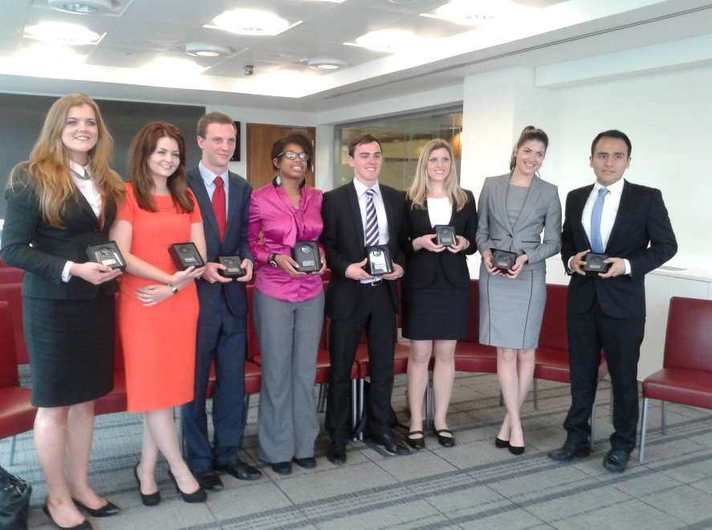
In early 2014 CHME – PATH hosted the first of 5 planned national Round Table discussions exploring the modern Hospitality Management Graduate and their fit into the hospitality industry of today and tomorrow.
The discussion, held at Southbank’s Brasserie Blanc, was sponsored by Jason Smith of Yummy Jobs. The event was attended by a mixture of representatives from universities, employers and industry represented bodies. The round table discussion explored the gap between the developed graduate skills and attributes in comparison to management expectations of a typical hospitality management graduate from a UK university.
This exciting and useful piece of research that is being organised by CHME-PATH is to help better align education with industry for current and future graduates. The first of the round tables took place in London and others are planned to follow across the UK. In total the research is to involve at least 15 universities and up to 50 senior industry representatives from England Scotland, Wales and Northern Ireland. CHME and its PATH group are excited to be coordinating this research.
Initial findings are indicating that Hospitality Graduates are mostly well prepared for the variety of the UK’s Hospitality sectors regarding their knowledge and industry skills, however employers are interested in the interpersonal skills being displayed by the student including passion and customer services skills beyond many other attributes “owned” by the graduate.
Crispin Farbrother Jason Smith
Co-Chair CHME Yummy Jobs

Young Guns
Congratulations to Lauren Joseph a Culinary Arts student from University College Birmingham and Martin Holden-White a Hospitality Management student from Oxford Brookes University who have just won the 2014 Young Guns. All candidates videos detailing why they should win can been seen on You Tube.

CHME PaTH update
The CHME executive committee are pleased to announce that CHME – PaTH has been through an exciting change process and has a new innovative approach to employer relations and engagement. We thank the previous committee for all their hard work and wish then every success in their new endeavor. CHME welcomes all organisations who are working towards improving the relationship between employers and universities for the benefit of students.
The new purpose for the CHME PaTH group is to focus on developing positive relationships between HEIs, Hospitality Employers and industry representative bodies, through a number of activities. 2014 will see the launch of two core activities.
In order to maximise benefits the group will be coordinating a number of Power Breakfasts across all CHME membership areas. The Power Breakfasts are planned to be short, high impact meetings between employers and universities in order to share best practice and develop positive local and national relationships. These meetings can of course include local hospitality associations and IoH branches.
In order to explore the views and opinions of various stakeholders, share knowledge and contribute to contemporary literature CHME PaTH have started to run focus groups across the UK. The focus groups will be hosted across the UK with at least 5 CHME member institutions hosting the first subject area in 2014.
Andy Roberts will chair the new group with support from Sophia Rebelo and they look forward to receiving support, encouragement and ideas for new CHME PaTH activities

Preparations for CHME Manchester 2015
already well under way.
Brand new presentation format Introduced for 2015.
As well as the traditional conference paper and poster formats, next year academics will be able to present their work in the Pecha Kucha format – 20 x 20 second slides. Outlines of potential research projects; ideas for research; actual proposals; commentaries on past research or other projects; elements of completed or partially completed projects may like to use this highly visual presentational approach.
Early Call for papers.
Full papers – of approximately 3000 words excluding references, these papers may be conceptual or empirical and should normally report on completed studies in one or more of the suggested track themes, however papers reporting on substantially developed work in progress will also be considered.
Posters – authors are encouraged to use posters as an alternative means of presenting their research. This may be a more appropriate format for reporting on less developed work in progress.
Pecha Kucha format – 20 x 20 second slides. Outlines of potential research projects; ideas for research; actual proposals; commentaries on past research or other projects; elements of completed or partially completed projects may like to use this highly visual presentational approach. Slide Submissions in this category will not be refereed but must be submitted prior to the conference for approval to present.
See http://www.pechakucha.org/
Submit your papers to chmemanchester@mmu.ac.uk

Hospitality Management: Track Chair: Dr Emma Martin: MMU Lead Staff: Dr Tim Jung/Amanda White
Critical and Cultural Studies of Hospitality: Track Chair: Dr Peter Lugosi: MMU Lead Staff: Sonia Anderson
LTA in Hospitality Management Education: Track Chair: Dr Paul Barron: MMU Lead Staff: Chris Mitchell/Richard Smith
Innovation, Creativity and Entrepreneurship in Hospitality: Track Chair: Carolyn Branston: MMU Lead Staff: Diane Connelly/Ed Belinski
Hospitality Customer and Worker Lifestyles, Futures and Experiences: Track Chair: Dr Tim Knowles: MMU Lead Staff: Dr Tim Knowles/Sue Moulding

Social Activities
We have planned an exciting array of social events, including a cocktail evening in the iconic Hilton Sky bar.
The Gala Dinner will be held at the Museum of Science and Industry, currently home to the Large Hadron Collider exhibit.

CHME Manchester Paper Themes
Early registration is already open for CHME Manchester, go to http://www.chmemanchester.org

CHME
Newsletter

CHME Twitter Account follow us @CHME2013
CHME External Examiner register
The CHME External Examiner Register is now up and running. This facility is only accessible to CHME members and already has 30 profiles registered. To either register your details or search for an examiner for your institution, you must enter your email and password. Any member of staff from a member institution can register. Anyone who has not yet registered can do so easily- the authorisation is automatic as soon as a request is made.
To access- click on the following link
http://www.chme.org.uk/external-examiner-register/external-examiner-registration-login/
AND Finally…….Congratulations to our very own Geoff Booth who won a Catey award for Education and Training. We are sure you will all join us in congratulating Geoff on this tremendous and well deserved accolade.

