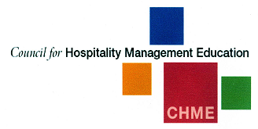 |  | CHME  - Newsletter  - April 2016

Chairs Report

Welcome to this edition of the Council for Hospitality Management Education newsletter. The committee continue to meet on a regular basis with the aim of representing hospitality education, developing links with the industry and providing a forum for the dissemination of research and innovation.
With the last point in mind, I would like to remind members of the forthcoming CHME conference scheduled for 4th to 6th May and hosted by Una and her team at Ulster University. Signs suggest that this will be a conference to remember with a significant number of papers and posters and a unique and innovative conference and social programme. Please encourage colleagues to attend. This is an ideal opportunity for researchers who may be less experienced to present their work in a friendly and collegiate atmosphere. Please visit https://www.ulster.ac.uk/campaigns/chme for full details.
Members of the Committee have been working on a number of initiatives over the past 6 months and this newsletter give me the opportunity to let members know what we have been doing. Such initiatives include raising the profile of CHME through the engagement of a Public Relations organisation; working toward the development of closer links between academia and industry, exploring various avenues of securing external
funding and sponsorship, and contributing to the QAA Hospitality subject statements.
The council finds itself in a relatively healthy financial position – mainly as a consequence of more proactive approach to the management of funds. This puts us in the fortunate position of considering how best we might utilise these funds. One area that has been suggested would be the financing of a research project that would benefit the Council, its members and hospitality education as a whole. I would be delighted to hear from any member who might have an idea of such a project and I will raise this at the next meeting. Please do not hesitate to contact me direct (p.barron@napier.ac.uk) to discuss this in greater detail.
Finally, I thought I would raise one contentious issue that is increasing in profile here in Edinburgh. As part of the £1billion City deal, Members of the City of Edinburgh Council are proposing the introduction of a Tourist Tax that would see around £1 per night added to the typical hotel bill. Initial thoughts are that this tax would be flexible, with guests at large hotels potentially paying more and raised or lowered in response to changing levels of demand, with a mooted £4 per night suggested during periods of peak demand. This is the first such tax of its type in the UK and, whilst the forthcoming Holyrood election makes this a political hot potato, there is strong backing for such a move. It is contended that such a scheme would be viewed with interest by leaders of councils throughout the UK and I think that this is we, as a council are ideally placed to commence a debate; undertake research and influence policy regarding this issue. Happy to hear your views.

Looking forward to seeing you in Ulster in May.
Professor Paul Barron
The Business School
Edinburgh Napier University
Craiglockhart Campus
Edinburgh
EH14 1DJ
United Kingdom
p.barron@napier.ac.uk

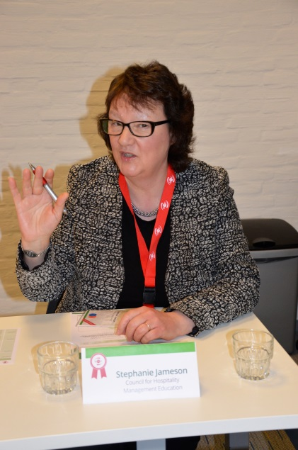
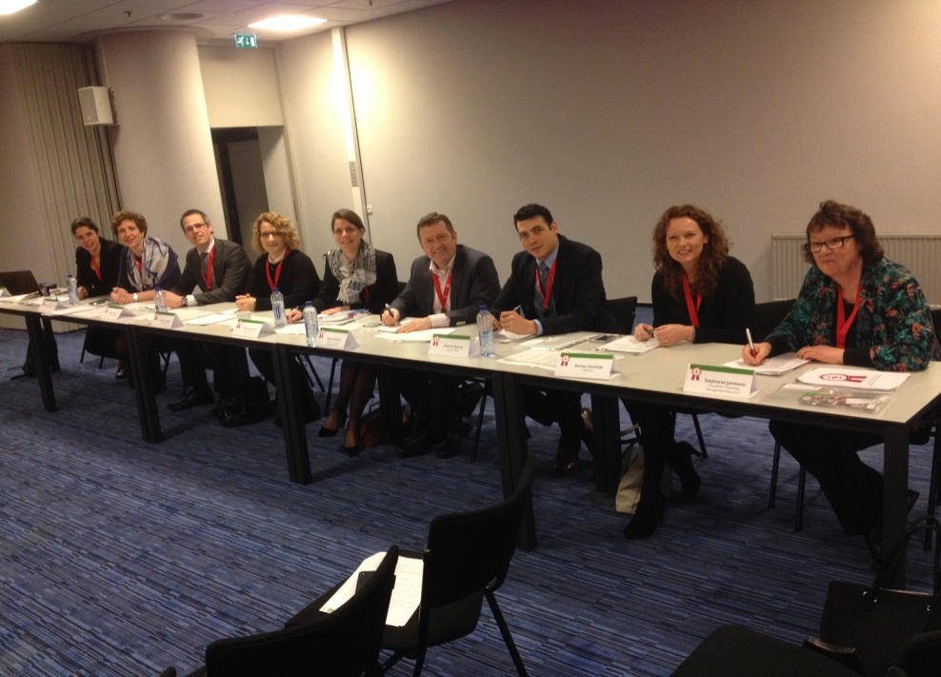
EMCUP 2016

Stephanie Jameson has just returned from Maastricht where she represented CHME at the European Mise en Place Cup. This is a competition involving the top hotel management schools in Europe. This year, 30 hotel schools from 14 different countries were in the competition. CHME members who were there included the University of Derby, Stenden University of Applied Sciences. the University College of Northern Denmark and Westminster Kingsway College.
Stephanie was Chair of the ‘Business Jury’ which comprised employers from 25 of the top hospitality companies in Europe.
The theme of this year’s competition was ‘Surfing the Silver Wave’ and students had to devise strategies and tactics for the hospitality industry to respond to the growth in an ageing population.

Critical Hospitality Studies Symposium
Edinburgh Napier University is hosting a Critical Hospitality Studies Symposium from 28-29 July 2016 (https:// chs2016.wordpress.com). The Symposium seeks to encourage multi-disciplinary conversations in critical hospitality and move beyond current discipline and subject silos. Critical Hospitality Studies is at a key stage in its development. The concept of Hospitality is employed by various disciplines as a way of investigating contemporary issues in society as well as being investigated as a phenomenon in its own right, for example, commercial, private, public hospitality. The study of hospitality is truly a multi-disciplinary phenomenon. In order to continue and progress its development it is important that scholars from different disciplines converse not just through multi-disciplinary journals such as Hospitality & Society but also in person. Such conversations are necessary to help build the networks required to develop the theoretical foundations and release the conceptual power of hospitality and to understand better the nature of the phenomenon.
The symposium invites scholars to participate from all disciplines concerned with usage of hospitality as a conceptual tool as well as those concerned with the study of hospitality in action. The organisers are keen to develop cross-disciplinary dialogue and we encourage contributions from colleagues working in anthropology, business and management, cultural and media studies, design, education, events, gender studies, geography, health and welfare, history, hospitality, language and literature studies, philosophy, sociology, sports and leisure studies, tourism, as well as related fields.
As a vehicle to bring together scholars from across a range of disciplines to explore hospitality in its myriad forms, contributions are invited exploring the themes below.

Hospitality as advocacy  Hospitality as biopolitics  Hospitality as boundaries  Hospitality as capital  Hospitality as care  Hospitality as control  Hospitality as culture  Hospitality as cyber politics  Hospitality as diplomacy  Hospitality as display  Hospitality as Earth  Hospitality as ethics | Hospitality as exchange  Hospitality as exclusion  Hospitality as gift  Hospitality as imperialism  Hospitality as inclusion  Hospitality as language  Hospitality as learning  Hospitality as life politics  Hospitality as management  Hospitality as memory  Hospitality as metaphor  Hospitality as politics | Hospitality as reciprocity  Hospitality as refuge  Hospitality as a relationship  Hospitality as shelter  Hospitality as society  Hospitality as a social lens  Hospitality as sovereignty  Hospitality as surveillance  Hospitality as welcome  Hospitality as work  We welcome other hospitality metaphors for exploration!

A note on metaphors…
Potential participants are referred to discussions of use of metaphors as a vehicle for the mobilisation of thought and theory enabling the exploration of ideas and practice. The discussion by Urry (2000:21) provides a good starting point: ‘Much of our understanding of society and social life is based upon, and reflected through, various metaphors.’ Further, ‘New meanings and realities are dependent upon diverse kinds of metaphorical thinking’ (22). A popular metaphor used to understand hospitality is that of hospitality as welcome (Derrida, 1999) which has become a much debated phenomenon. We hope that exploration of a wider range of metaphors of hospitality may be similarly fertile ground for advancing our understanding of issues surrounding hospitality.
References and Further Reading
Derrida, J. (1999) Adieu to Emmanuel Levinas, Brault, P. and Nass, M. (trans.), Stanford, CA, Stanford University Press Books.
Gibson, S. (2007) ‘Abusing our Hospitality’: Inhospitableness and the Politics of Deterrence. In Molz, J.G. and Gibson, S. (eds.) Mobilizing Hospitality: The Ethics of Social Relations in a Mobile World, Ashgate, Aldershot, pp. 159-176.
Lynch, P., Molz, J., McIntosh, A., Lugosi, P. and Lashley, C. (2011) Theorizing Hospitality, Hospitality & Society, 1(1): 3-24.
Morgan, G. (2006) Images of Organization, Thousand Oaks, CA: Sage.
Urry, J. (2000) Sociology Beyond Societies: Mobilities for the twenty-first century, London: Routledge.

Critical Hospitality Studies Symposium

Edinburgh Napier University

28-29 July 2016
prof. Paul Lynch

Peter Lugosi and Stephanie Jameson
Teaching and Learning Issues in Hospitality

The origin of this project was an initiative from the Higher Education Academy (HEA) who were conducting research into the state of university-level learning and teaching in a wide range of subject disciplines in order to better understand the sector’s needs. The HEA are now using the research to develop strategies to support higher education pedagogy.
The HEA chose CHME to represent the hospitality subject discipline and to conduct research into learning and teaching issues in this area. The data for this report were generated from four focus groups and the sample was made up of colleagues from 12 higher education institutions in Scotland, Wales, England and Northern Ireland. Participants had taught hospitality at undergraduate and postgraduate levels and the majority had course management responsibilities.
It was extremely useful and timely to have had the opportunity to discuss with colleagues from different backgrounds and different institutions how they felt hospitality is being taught (and learned) now and how it will develop in the future. There is no doubt that the sector in general and hospitality education in particular is facing challenges but the colleagues involved in the four focus groups also highlighted the many innovative ways that individuals and institutions were responding to emerging challenges.
Here are some of the key findings:
-Colleagues felt that many of the off-the-shelf textbooks and online resources
were not tailored enough for hospitality students.
-Many colleagues adopted a ‘magpie’ approach to gathering useful material to use in their teaching.
-Colleagues were seen as the strongest resource for teaching but also for knowledge transfer.
-It was increasingly difficult to engage contemporary students who wanted easy access to complex information.
-The growing internationalisation of higher education continues to generate new challenges for recruitment, competition and classroom engagement.
-Institutional pressures to develop ‘efficient’ course designs, involving large, generic modules taught across courses, were often seen to compromise deep learning and specialist hospitality focus.
-Colleagues outlined how technologies could become threats to student engagement, but also how they were used to enhance teaching and learning.
-Practical facilities, though financially costly and politically sensitive issues in universities, were still seen as assets for those institutions who maintained them.
-Expanding cultures of metrification and the incorporation of hospitality courses and departments into business schools were seen as threats by many colleagues.
-Colleagues felt strongly about remaining relevant to the sector and developing employable students, but they were also mindful that higher education should not just mass-produce workers for the sectors.

Full details of the study’s findings will be presented at the forthcoming conference at Ulster University in May.

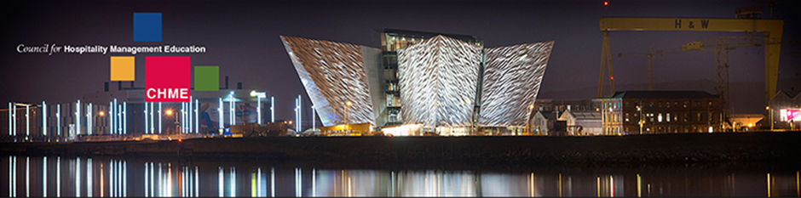

CHME 2016

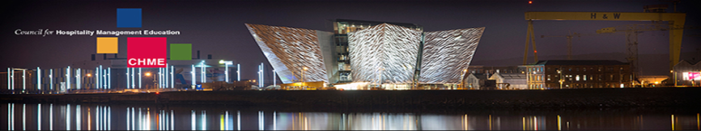

With hospitality and tourism in Northern Ireland seeing continued growth and 2016 shaping up to be an important year for tourism with initiatives such as the Year of Food and Drink, Ulster University Business School is proud to bring the 25th Council for Hospitality Management Education (CHME) Conference to Belfast from 4th- 6th May.

by
This conference provides an open forum in which a wide range of themes linked to hospitality will be debated, including the importance of education and training in the sector, the factors and trends influencing hospitality, as well as key innovations in food and drink and niche tourism. The conference will bring together leading international hospitality academics as well as industry practitioners and policy makers to debate and showcase innovative and best practice for further development and progression of the hospitality industry. Keynote speakers include Dr Ian Yeoman (Victoria University of Wellington in New Zealand) a leading tourism and hospitality futurist, Dr Francesca Zampollo (International Food Design Consultant) a renowned international expert on food design and innovation, and the University’s own Professor Peter Walker (Head of the Belfast School of Architecture).
Findings from a range of innovative industry research projects will offer delegates the opportunity to disseminate, debate and discuss best practice and the important issues that need to be considered for the hospitality industry to flourish and grow.
The conference will provide the opportunity to hear how this has been achieved elsewhere from both international and local experts in their field. Special industry focused workshops will also be provided, such as STR Global’s ‘Certification in Hotel Industry Analytics’ and ‘Train the Trainer’ sessions and the HOTS Simulation. Evening social events will also take place for delegates at Belfast City Hall and the Belfast Harbour Commissioners Office, both of which are stunning buildings offering excellent hospitality.
The event will take place on the University’s Belfast Campus from 4th- 6th May and further information can be found at www.ulster.ac.uk/chme16 and you can follow on twitter via #CHME16. There is still time to register your interest and attend the conference in what has been recognised as one of the UK’s top Tourist Cities to Visit.

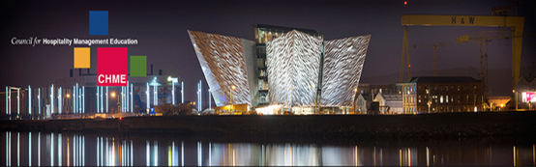

CHME Conference 2016

YOUNG GUNS 2016

Following an excellent lunch hosted by Lexington Catering in Central London in March and a tough interview process for all the finalists, the winners of the 2016 Young Guns can be announced. They are Harriet Smales from Oxford Brookes and Oscar Clark from Sheffield Hallam. Well done to the 8 finalists - Fayme Patel and Lara Senhen from Robert Gordon University, Aberdeen; David Klein from the International University of Applied Sciences, Bad Honnef; Julia Jefferis from Leeds Beckett University; Oscar Clark and Richard Edmond from Sheffield Hallam; Stephanie Banfield from Bournemouth University and Harriet Smales from Oxford Brookes.
Oscar described how gaining recognition and chance to network with the judges through Young Guns had been the highlight of his day. For Harriet the whole experience “has been out of this world”.
Oscar and Harriet have now received one year’s membership into the Institute of Hospitality; described by Peter Ducker, Chief Executive of the Institute, as something that “brings them into the network” of key hospitality contacts as well as giving them unique access into the current research being undertaken within the industry.
The membership and fellow members within the institute will act as a support network for these young aspiring students and therefore the opportunities that Young Guns provide are unlimited!
Harriet kindly offered some advice for the potential candidates for next year’s competition, saying that to have a chance you need to “portray your passion for your industry”. Oscar adds “This is an award about the future, it is about what you can do and what you’re going to do”.

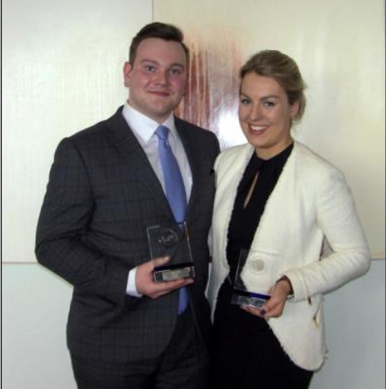

CHME
Newsletter

