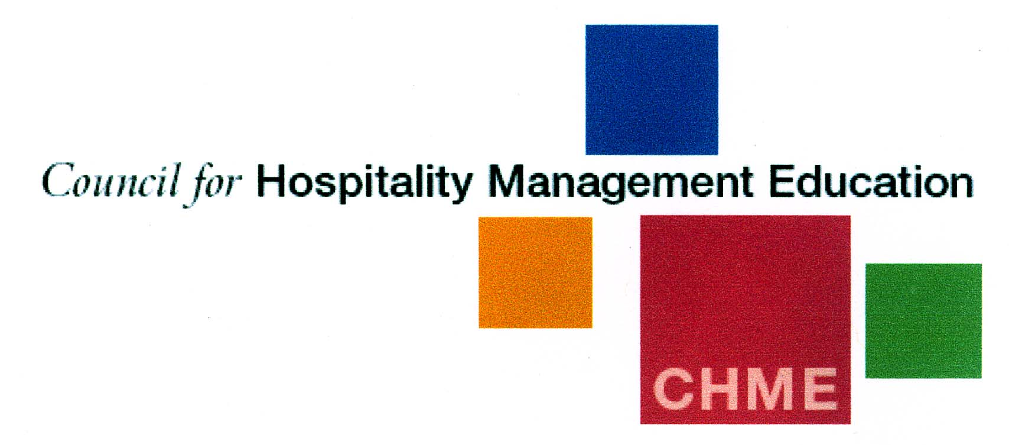
CHME - Young Guns Hospitality Student of the Year Award 2017
I am delighted to announce that applications for the 2017 CHME Young Guns Hospitality Student of the Year Award competition are now open. Young Guns is a very prestigious competition for FINAL YEAR university and college students who have completed their Hospitality Industry placements in the past TWO years. The university or college must be a member of CHME.
The competition is supported by key chief executives from a number of hospitality companies. It is a great opportunity for Universities and Colleges to demonstrate their 'output' directly to the business community. Equally parents and aspiring students may find a university with such accolades more appealing than others who seem to have less engagement. Winners not only gain accolades for themselves but also add prestige to their university or college.
Please encourage your students to apply! The process is simple…students are asked to complete an application form and make a video of no longer than 90 seconds, which is to be uploaded to YouTube, covering why they should win the competition, what job role they see themselves in five years’ time and what they enjoy most about the industry.
The nominating tutor should then complete the application form which will include a short reference (no more than 150 words). This may be from the placement manager of the appropriate placement organisation. The form is then to be sent to i.r.hodgson@sky.com. Should any of these elements be missing unfortunately we cannot include the student in the shortlisting process as their application will be incomplete.
The deadline for applications is the 1st December 2016 - following receipt of the entries 8 successful applicants will be shortlisted and invited to attend the judging and awards presentation day on the 8th March 2017 in London courtesy of The RAF Club, Piccadilly.
The two successful winners will receive a selection of prizes including 1year membership of the Institute of Hospitality and 1 year’s subscription to the Caterer, attendance at the Catey Awards in July. The event provides opportunities to network with the most senior and high profile members of the Hospitality Industry.
If you have any questions, please do let me know however I look forward to receiving your entries!
Isabell R Hodgson
CHME Coordinator Email- i.r.hodgson@sky.com

