Young Guns 2018
The CHME Young Guns competition final once again took place at the prestigious RAC Club in Central London. The winners this year were Harry Champion from Bournemouth and Mia Jorjikia from Oxford Brookes University.
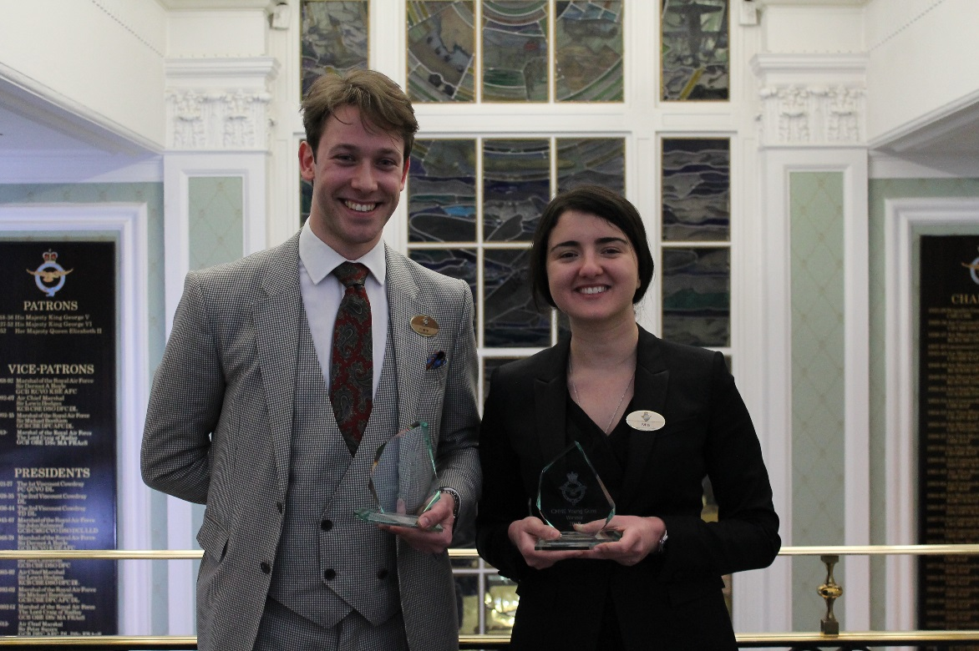

The event was covered by the Caterer:
https://www.thecaterer.com/articles/522633/young-guns-2018-winners-revealed
Well done to all the runners up as well!
